**DATA VISUALIZATION**

* Data visualization is the graphical representation of information and data.
* By using visual elements like charts, graphs, and maps, data visualization tools provide an accessible way to see and understand trends, outliers, and patterns in data.
* In the world of Big Data, data visualization tools and technologies are essential to analyze massive amounts of information and make data-driven decisions.

Data visualization convert large and small data sets into visuals, which is easy to understand and process for humans.

In the world of Big Data, the data visualization tools and technologies are required to analyze vast amounts of information.

Data visualizations are common in your everyday life, but they always appear in the form of graphs and charts. The combination of multiple visualizations and bits of information are still referred to as Infographics.

Data visualizations are used to discover unknown facts and trends. You can see visualizations in the form of line charts to display change over time. Bar and column charts are useful for observing relationships and making comparisons. A pie chart is a great way to show parts-of-a-whole.

**HISTORICAL OVERVIEW OF DATA VISUALIZATION**

A historical overview of data visualization reveals how humans have been using various techniques to represent data for centuries. Here's a brief overview of the evolution of data visualization throughout history:

**1. Prehistoric and Ancient Times:**

• Early humans used simple drawings, symbols, and marks to record events, such as hunting and agricultural activities, on cave walls and stones.

• Ancient civilizations, like the Egyptians and Mesopotamians, used hieroglyphics and cuneiform script to document information.

**2. Medieval and Renaissance Periods (500-1600 CE):**

• During the Middle Ages, illuminated manuscripts incorporated intricate illustrations and diagrams to convey information.

• In the Renaissance, artists like Leonardo da Vinci used detailed sketches and diagrams to document scientific observations and inventions.

**3. 17th and 18th Centuries:**

• The Enlightenment era saw the development of charts, graphs, and diagrams to represent scientific data. For example, Galileo used line charts to depict planetary motion.

• The emergence of statistical graphics, including bar charts and histograms, gained prominence with the work of William Playfair and others.

**4. 19th Century:**

• Florence Nightingale, a nurse and statistician, pioneered the use of graphical representations to illustrate the impact of sanitation on mortality rates during the Crimean War.

• John Snow's famous cholera map in 1854 used a map overlay to visualize the spread of the disease in London.

**5. 20th Century:**

• The 20th century witnessed significant advancements in data visualization, driven by technological innovations.

• Early computer graphics and digital plotting allowed for the creation of more complex and dynamic visualizations.

• Pioneers like Jacques Bertin and Edward Tufte contributed to the development of principles for effective data visualization.

**6. Late 20th to 21st Century:**

• The advent of personal computers and software tools like Excel and Tableau made data visualization accessible to a broader audience.

• Interactive data visualizations on the web, often using JavaScript libraries like D3.js, became increasingly popular.

• Infographics, dashboards, and data journalism became integral parts of modern communication and journalism.

**7. Contemporary Trends (21st Century):**

• Big data and the availability of vast amounts of information have led to the development of advanced visualization techniques, including 3D visualizations, virtual reality (VR), and augmented reality (AR).

• Machine learning and AI are being used to automate data visualization and generate insights from complex datasets.

• Data visualization is now integral to fields like data science, business intelligence, and decision-making across various industries.

**Importance of Data Visualization**

Data visualization is important because of the processing of information in human brains. Using graphs and charts to visualize a large amount of the complex data sets is more comfortable in comparison to studying the spreadsheet and reports.

Data visualization is an easy and quick way to convey concepts universally. You can experiment with a different outline by making a slight adjustment.

**Data visualization have some more specialties such as:**

AD

* Data visualization can identify areas that need improvement or modifications.
* Data visualization can clarify which factor influence customer behavior.
* Data visualization helps you to understand which products to place where.
* Data visualization can predict sales volumes.

**Why Use Data Visualization?**

1. To make easier in understand and remember.
2. To discover unknown facts, outliers, and trends.
3. To visualize relationships and patterns quickly.
4. To ask a better question and make better decisions.
5. To competitive analyze.
6. To improve insights.

**Application of data visualization**

Data visualization has a wide range of applications across various fields and industries. Its primary purpose is to make complex data more accessible, understandable, and actionable by presenting it in a visual format. Here are some key applications of data visualization:

**1.Business and Finance:**

• Financial Analysis: Visualizations like line charts, candlestick charts, and heatmaps are used to analyze stock prices, market trends, and investment portfolios.

• Business Dashboards: Interactive dashboards provide real-time insights into key performance indicators (KPIs), sales data, and operational metrics.

**2.Healthcare and Medicine:**

• Medical Imaging: Techniques like MRI and CT scans generate complex medical images, which are often visualized in 2D and 3D to aid in diagnosis and treatment planning.

• Epidemiology: Visualizations of disease outbreaks, vaccination coverage, and healthcare data help in monitoring and responding to public health crises.

**3.Science and Research:**

• Scientific Data Analysis: Visualizations assist scientists in understanding and communicating research findings, whether in fields like physics, biology, or astronomy.

• Genomics: Genetic data is often visualized using diagrams and charts to identify patterns and variations.

**4.Marketing and Advertising:**

• Marketing Campaign Analysis: Marketers use charts and graphs to assess the performance of advertising campaigns, website traffic, and customer behavior.

• Customer Segmentation: Visualizations help identify customer segments based on demographics, behavior, and preferences.

**5.Education and E-Learning:**

• Educational Dashboards: Visual dashboards provide educators and students with insights into academic performance, progress, and areas for improvement.

• Interactive Learning: Visualizations aid in explaining complex concepts through interactive graphics and simulations.

**6.Government and Public Policy:**

• Public Policy Analysis: Governments use data visualizations to communicate policy impacts, budgets, and election results to the public.

• Geospatial Mapping: Geographic information systems (GIS) visualize data on maps for urban planning, disaster response, and environmental analysis.

**7.Sports Analytics:**

• Performance Analysis: Coaches and analysts use visualizations to assess player performance, track game statistics, and develop game strategies.

• Fan Engagement: Visualizations enhance the fan experience by providing real-time statistics during sports broadcasts.

**8.Manufacturing and Supply Chain:**

• Supply Chain Visibility: Visualizations help in tracking inventory, optimizing logistics, and ensuring efficient production processes.

**type**

### **1. Pie Chart**

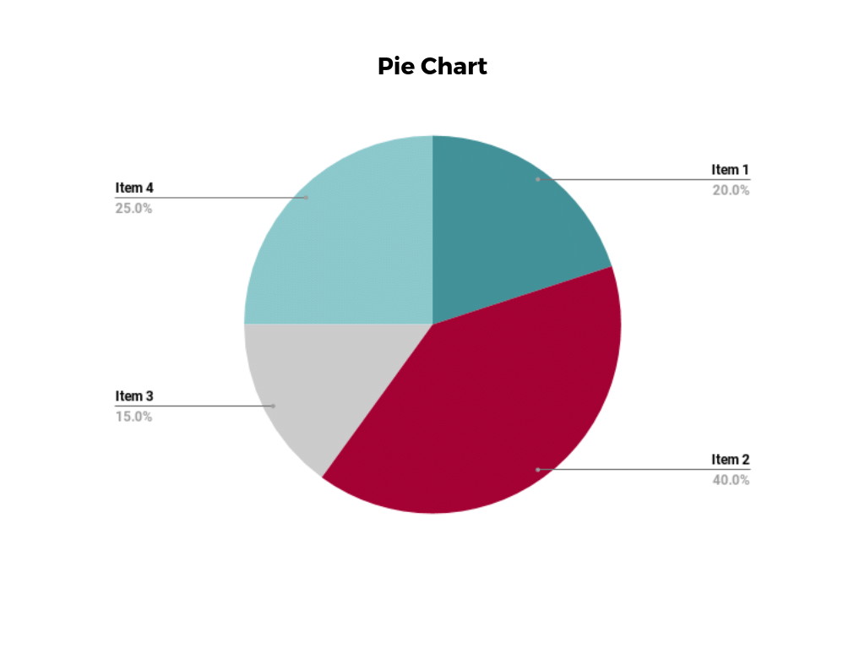

**Pie charts** are one of the most common and basic data visualization techniques, used across a wide range of applications. Pie charts are ideal for illustrating proportions, or part-to-whole comparisons.

Because pie charts are relatively simple and easy to read, they’re best suited for audiences who might be unfamiliar with the information or are only interested in the key takeaways. For viewers who require a more thorough explanation of the data, pie charts fall short in their ability to display complex information.

### **2. Bar Chart**

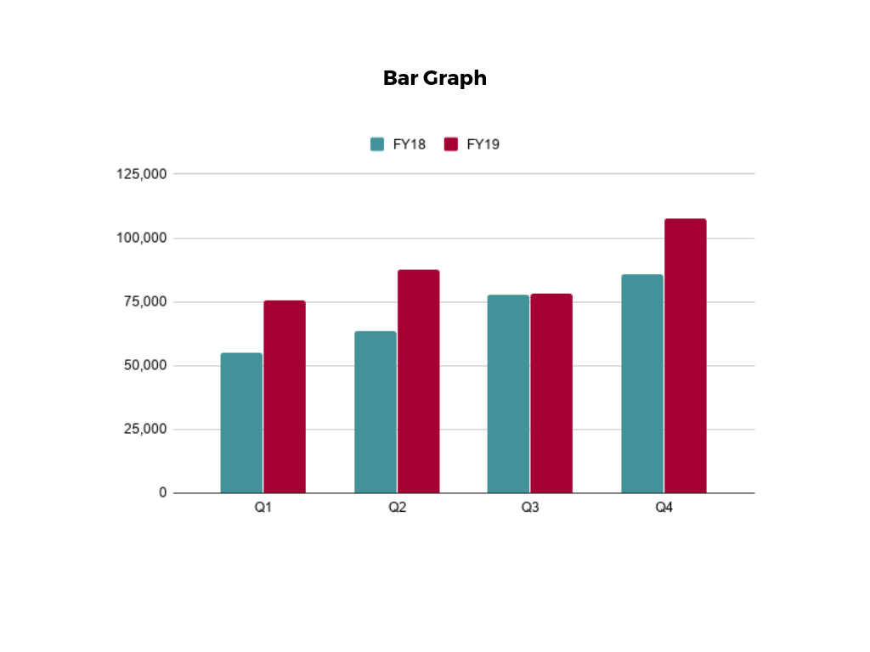

The classic **bar chart**, or bar graph, is another common and easy-to-use method of data visualization. In this type of visualization, one axis of the chart shows the categories being compared, and the other, a measured value. The length of the bar indicates how each group measures according to the value.

One drawback is that labeling and clarity can become problematic when there are too many categories included. Like pie charts, they can also be too simple for more complex data sets.

### **3. Histogram**

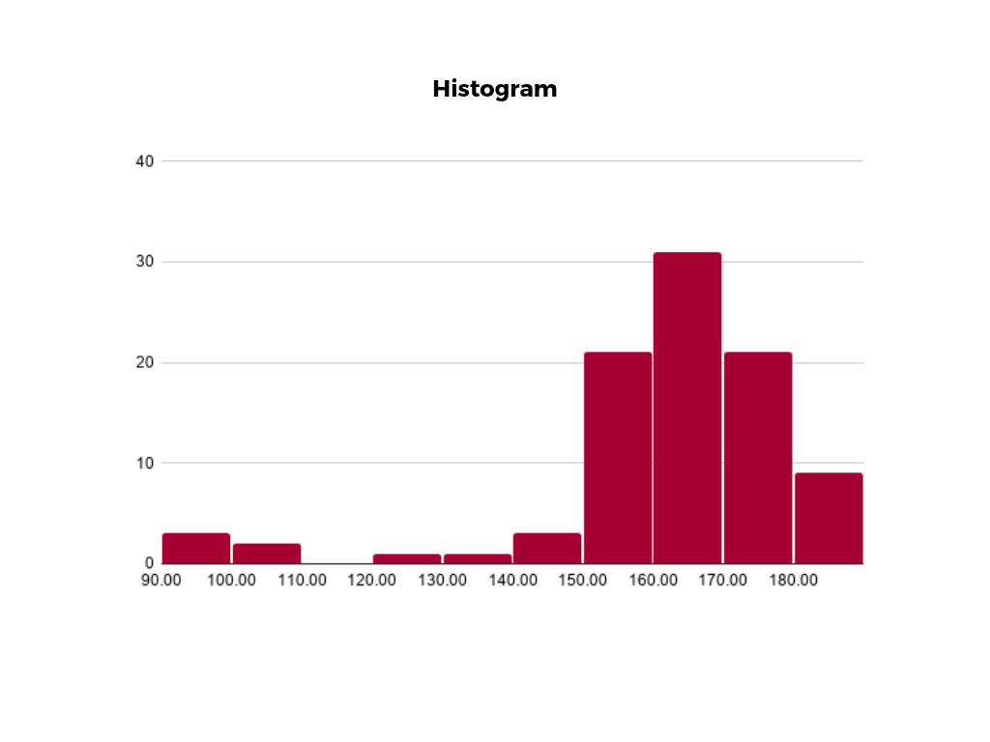

Unlike bar charts, **histograms** illustrate the distribution of data over a continuous interval or defined period. These visualizations are helpful in identifying where values are concentrated, as well as where there are gaps or unusual values.

Histograms are especially useful for showing the frequency of a particular occurrence. For instance, if you’d like to show how many clicks your website received each day over the last week, you can use a histogram. From this visualization, you can quickly determine which days your website saw the greatest and fewest number of clicks.

### **4. Waterfall Chart**

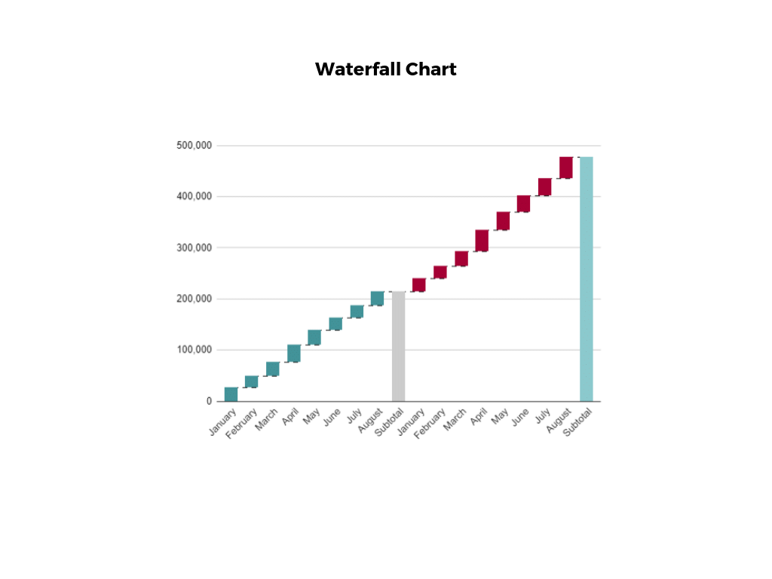

A **waterfall chart** is a visual representation that illustrates how a value changes as it’s influenced by different factors, such as time. The main goal of this chart is to show the viewer how a value has grown or declined over a defined period. For example, waterfall charts are popular for showing spending or earnings over time.

### **5. Area Chart**

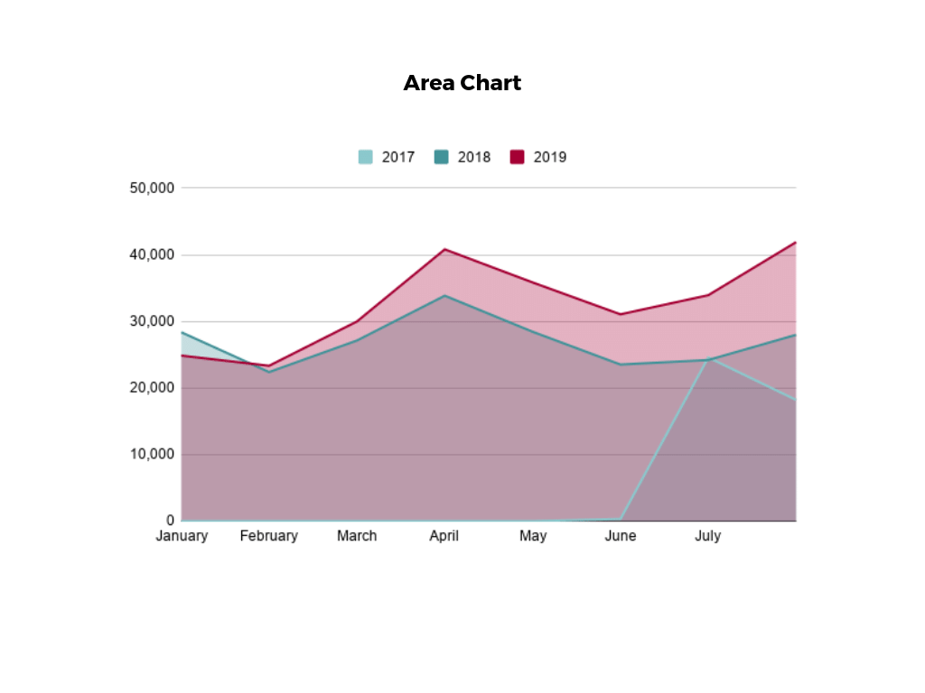

An **area chart**, or area graph, is a variation on a basic line graph in which the area underneath the line is shaded to represent the total value of each data point. When several data series must be compared on the same graph, stacked area charts are used.

This method of data visualization is useful for showing changes in one or more quantities over time, as well as showing how each quantity combines to make up the whole. Stacked area charts are effective in showing part-to-whole comparisons.

### **6. Scatter Plot**

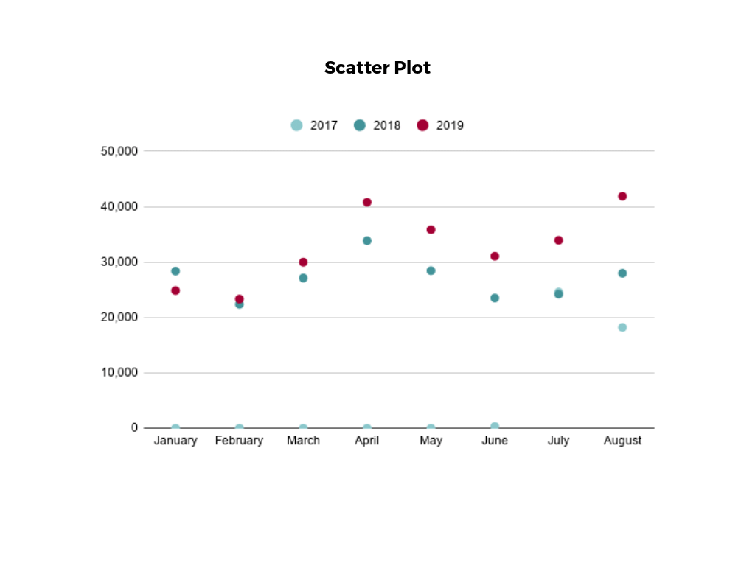

Another technique commonly used to display data is a **scatter plot**. A scatter plot displays data for two variables as represented by points plotted against the horizontal and vertical axis. This type of data visualization is useful in illustrating the relationships that exist between variables and can be used to identify trends or correlations in data.

Scatter plots are most effective for fairly large data sets, since it’s often easier to identify trends when there are more data points present. Additionally, the closer the data points are grouped together, the stronger the correlation or trend tends to be.

### **7. Pictogram Chart**

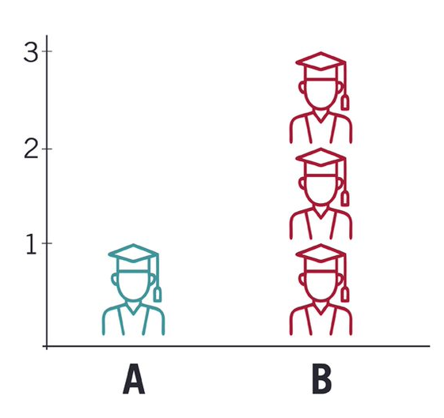

**Pictogram charts**, or pictograph charts, are particularly useful for presenting simple data in a more visual and engaging way. These charts use icons to visualize data, with each icon representing a different value or category. For example, data about time might be represented by icons of clocks or watches. Each icon can correspond to either a single unit or a set number of units (for example, each icon represents 100 units).

In addition to making the data more engaging, pictogram charts are helpful in situations where language or cultural differences might be a barrier to the audience’s understanding of the data.

### **8. Timeline**

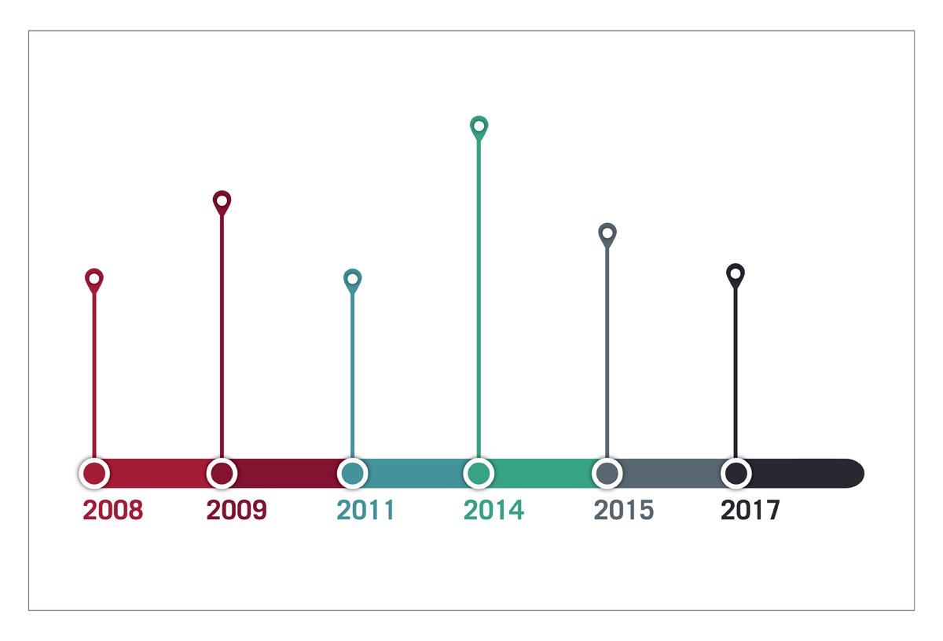

**Timelines** are the most effective way to visualize a sequence of events in chronological order. They’re typically linear, with key events outlined along the axis. Timelines are used to communicate time-related information and display historical data.

Timelines allow you to highlight the most important events that occurred, or need to occur in the future, and make it easy for the viewer to identify any patterns appearing within the selected time period. While timelines are often relatively simple linear visualizations, they can be made more visually appealing by adding images, colors, fonts, and decorative shapes.

**DATA VISUALIZATION TOOLs**

**Tableau** is a powerful data visualization and business intelligence (BI) software tool that helps organizations turn raw data into meaningful insights. It was acquired by Salesforce in 2019 and is now part of the Salesforce ecosystem. Tableau provides a user-friendly and interactive interface for creating a wide range of visualizations and dashboards, making it a popular choice for data analysts, business analysts, and data professionals.

Here are some key features and aspects of Tableau:

**Data Connection:** Tableau can connect to various data sources, including databases, spreadsheets, cloud services, and more. It allows users to import and blend data from different sources to create a unified dataset.

**Data Preparation:** Tableau offers basic data preparation capabilities to clean, transform, and shape data for analysis. However, for more advanced data wrangling tasks, users may need to integrate Tableau with other data preparation tools.

**Visualization:** Tableau provides a wide range of visualization options, including bar charts, line charts, scatter plots, heat maps, and geographic maps. Users can drag and drop data fields onto the canvas to create interactive visualizations.

**Dashboards:** Users can combine multiple visualizations into interactive dashboards, allowing for a comprehensive view of data. Dashboards can include filters, actions, and parameters to facilitate data exploration.

**Interactivity:** Tableau emphasizes interactivity, allowing users to explore data by interacting with visualizations. You can filter, highlight, and drill down into data points to uncover insights.

**Sharing and Collaboration:** Tableau allows users to publish and share their visualizations and dashboards with others. These can be embedded in websites, shared via links, or accessed through the Tableau Server or Tableau Online platforms.

**Security:** Tableau provides robust security features to ensure that data is accessed and shared securely. It supports authentication, authorization, and encryption.

**Advanced Analytics:** While Tableau is primarily a visualization tool, it also offers integration with advanced analytics platforms and languages like R and Python for performing statistical analysis and predictive modeling.

**Mobile Accessibility:** Tableau offers mobile apps and responsive designs for dashboards, making it accessible on a wide range of devices.

**Extensions and APIs:** Tableau supports extensions and APIs that allow developers to customize and extend its functionality, integrating it with other applications and services.

**Power BI**

is a business intelligence (BI) and data visualization tool developed by Microsoft. It enables users to connect to various data sources, transform and prepare data, create interactive reports and dashboards, and share insights with others. Power BI is widely used by organizations to gain valuable insights from their data and make data-driven decisions. Here are some key features and aspects of Power BI:

**Data Connection:** Power BI can connect to a wide range of data sources, including databases, spreadsheets, cloud-based services, and web services. It supports both on-premises and cloud-based data connections.

**Data Transformation:** Power BI includes a Power Query Editor that allows users to clean, transform, and shape data from multiple sources. This data preparation step is crucial for creating meaningful visualizations.

**Data Modeling:** Power BI uses a data modeling language called DAX (Data Analysis Expressions) to create calculations, calculated columns, and measures. This allows users to perform complex calculations and create custom metrics.

**Visualizations:** Power BI offers a wide variety of interactive data visualization options, including bar charts, line charts, pie charts, maps, tables, and custom visuals. Users can drag and drop fields onto the canvas to create visualizations easily.

**Dashboards:** Users can create interactive dashboards by pinning visualizations and reports to a single canvas. Dashboards provide a consolidated view of important metrics and KPIs.

**Natural Language Query**: Power BI includes a feature called "Q&A" that allows users to ask questions about their data using natural language. It generates visualizations based on the questions asked.

**Sharing and Collaboration:** Power BI supports sharing reports and dashboards with others within or outside the organization. It offers options for embedding reports in websites and applications and allows for scheduled data refreshes.

**Security:** Power BI provides robust security features, including role-based access control (RBAC) and data-level security. This ensures that users only see data relevant to their roles and permissions.

**Integration:** Power BI integrates seamlessly with other Microsoft products such as Excel, Azure, and SharePoint. It also has connectors for many third-party services and applications.

**Mobile Accessibility:** Power BI offers mobile apps for iOS and Android devices, allowing users to access and interact with reports and dashboards on the go.

**AI and Machine Learning:** Power BI integrates with Azure Machine Learning, enabling users to leverage machine learning models and AI capabilities to gain deeper insights from their data.

Power BI is available in multiple editions, including Power BI Desktop (for creating reports and visualizations), Power BI Pro (for sharing and collaboration), and Power BI Premium (for enterprise-level deployments with enhanced performance and scalability).

**EXCEL**

Microsoft Excel is a widely used spreadsheet application developed by Microsoft. It is part of the Microsoft Office suite of productivity software and is available for both Windows and macOS operating systems. Excel is primarily used for tasks involving data entry, analysis, calculation, and visualization. Here are some key features and aspects of Microsoft Excel:

**Spreadsheet Structure:** Excel uses a grid of rows and columns to organize data, with each intersection of a row and column referred to as a cell. Cells can contain various types of data, including numbers, text, dates, and formulas.

**Formulas and Functions:** Excel provides a powerful formula and function system that allows users to perform calculations on data. Functions are pre-built formulas that perform specific tasks, such as SUM, AVERAGE, and IF. Users can also create custom formulas using operators and functions.

**Data Analysis:** Excel is commonly used for data analysis tasks, including sorting, filtering, and creating pivot tables to summarize and analyze large datasets. What-If Analysis tools like Data Tables and Scenario Manager are also available for performing simulations and sensitivity analysis.

**Charts and Graphs:** Excel offers a variety of chart types, such as bar charts, line graphs, pie charts, and scatter plots. Users can create visually appealing charts to represent data and trends.

**Data Validation:** Excel allows users to set rules and validation criteria for cells to ensure data accuracy. This can include data validation lists, date restrictions, and custom validation rules.

**Data Import and Export:** Excel can import data from various sources, including text files, databases, and web services. Users can also export Excel data to other formats like CSV or PDF.

**Macros and Automation:** Excel supports Visual Basic for Applications (VBA), which enables users to automate tasks and create custom macros to streamline repetitive processes.

**Collaboration:** Excel supports collaboration features, such as real-time co-authoring in Excel Online and sharing workbooks via OneDrive or SharePoint. Users can also add comments and track changes made to a workbook.

**Templates:** Excel provides a wide range of templates for different purposes, including budgeting, project management, and financial analysis. Users can start with these templates and customize them to suit their specific needs.

**Conditional Formatting:** Users can apply conditional formatting to cells based on specific conditions. This helps highlight data trends and make spreadsheets more visually informative.

**Security:** Excel allows users to protect workbooks and sheets with passwords to control access to sensitive data. It also supports encryption for data security.

**Integration:** Excel can integrate with other Microsoft Office applications, such as Word and PowerPoint. It also supports data connections to external sources, including SQL databases and web services.